**Trash & recycling pick-up routes**

The City of Smithville’s contract for residential solid waste and recycling collection with GFL Environmental became effective in November 2021. Residents must use the GFL-provided containers for all household trash and recycling materials.

To ensure proper collection, containers must be placed at the curb with the wheels and handle facing the house and must be at least three feet away from any obstructions such as mailboxes, vehicles, or other containers. Placing the containers on either side of your driveway is recommended to give the collection truck’s mechanical arm adequate space to lift and empty the carts safely.

All containers must be set out by 6:30 AM on your scheduled collection day. Both trash and recycling are collected weekly. All materials must fit inside the designated containers. Loose bags, boxes, or overflow items will not be collected.

Please see the routes below to determine your trash & recycling day:

**Monday**:

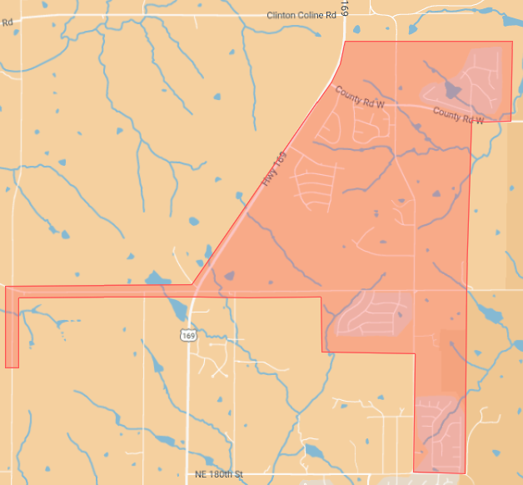

F HWY

NW 188TH ST

Lake Meadows

Diamond Crest

Harbor Lake

Tradewinds

Wildflower

Rollins Landing

**Tuesday:**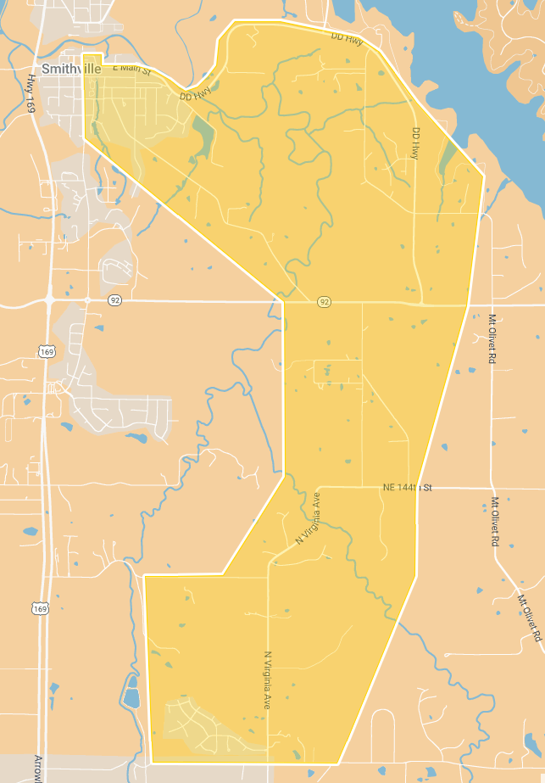

NE Amory Rd

Wise Rd

Liberty St

Forest Oaks

N. Virginia

Tillman & Wise Roads

Liberty Road

Liberty Street

Lakeside Crossing

Old Smithville East of Commercial & South of the river

**Wednesday:**

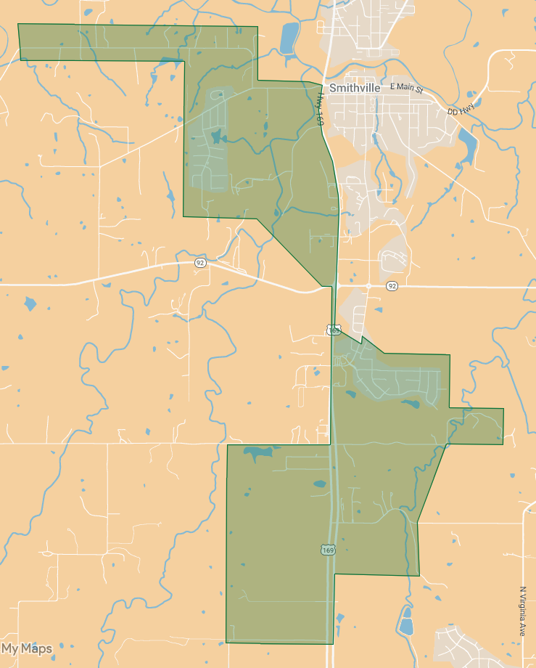

SHANNON AVE

NW 134TH ST

NW 144TH ST

NW 164TH ST

Woods Court

134th Street

Hills of Shannon

Barton Heights

Cedar Lakes

Lowman Road

Ashmont

**Thursday:**

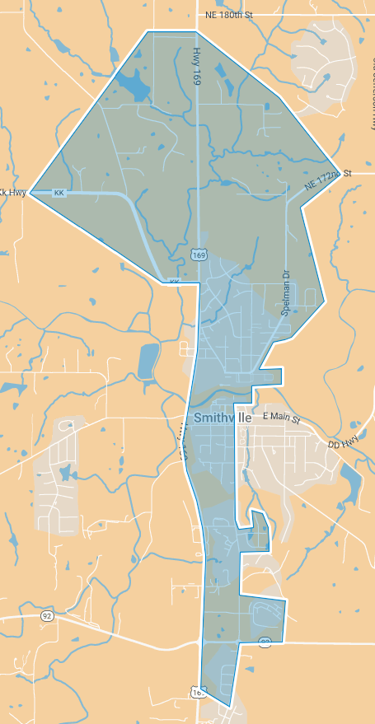

Pope Ln

Emerald Ridge

Stonebridge

Commercial Street

Downtown Smithville West of Commercial

Old Smithville North of the river

Old Jefferson Hwy

Pope Lane

Hillcrest Subdivision

KK Hwy

Cliff Drive

**Friday:**

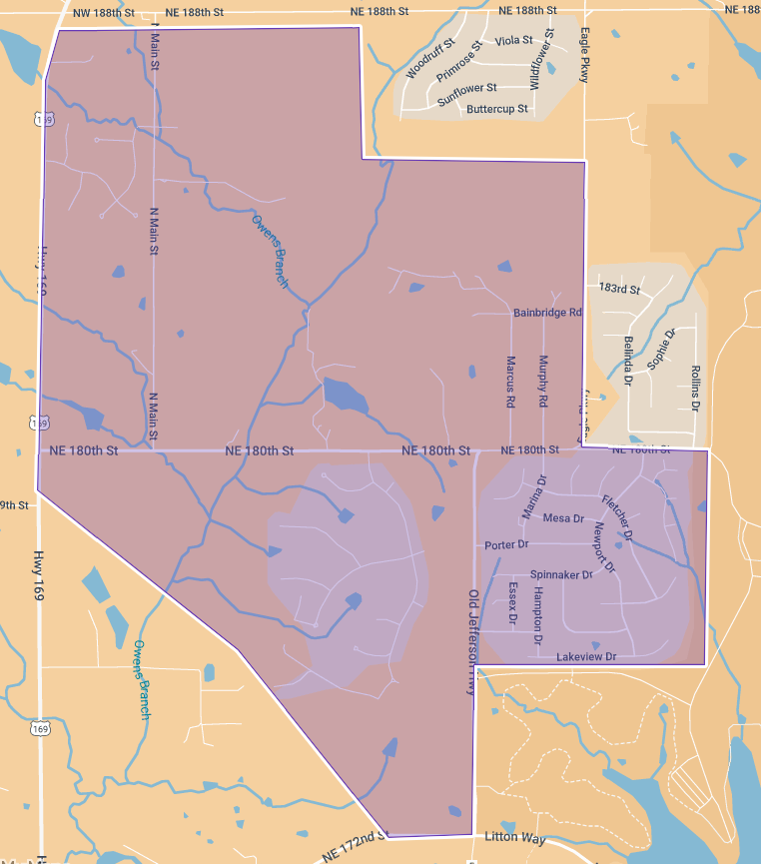

HARBORVIEW

N MAIN ST

NE 180TH ST

GREYHAWKE

ROCK CREEK